CS 6650 Assignment 2
----------------------------------------Git Repository URL----------------------------------------------

--------------------------------------Architecture Document------------------------------------------
Key discoveries
- Local Client Outperformed EC2 Client Initially

Expected: EC2 client closer to server → lower latency → higher throughput.

Actual: Local client (44329msg/sec) was initially comparable to EC2 client (40,219 msg/sec).

- Load Balancing Initially Hurt Performance

Expected: 2 servers → ~2× throughput improvement.

Actual: 2 servers with 20 consumers dropped to 16,083 msg/sec — worse than single instance.

- More Client Threads Hurt Performance

Expected: 64 client threads → higher throughput than 20 threads.

Actual: 64 threads was 60% slower than 20 threads

- Consumer Thread Count Is a Critical Tuning Parameter

Expected: Consumer threads have minimal impact on throughput.

Actual: Doubling consumers from 20 to 40 improved throughput by 20% (30,219 → 36,389 msg/sec).

- Queue Depth Target Was Not Met

Expected: Queue depth consistently < 1,000 messages.

Actual: Queue depth peaked at ~14,000 messages under EC2 client load. At best, my queue depth was still around 5000. This was due to the producer rate being much higher than consumer rate, I tried to change several metrics, including the channel pool size, the blocking queue in between message generator and message sender, but none of those worked. I also tried my best to increase consumer rate, but adding more consumer threads and instances did not work well either, probably due to EC2 memory limitation.

System architecture:

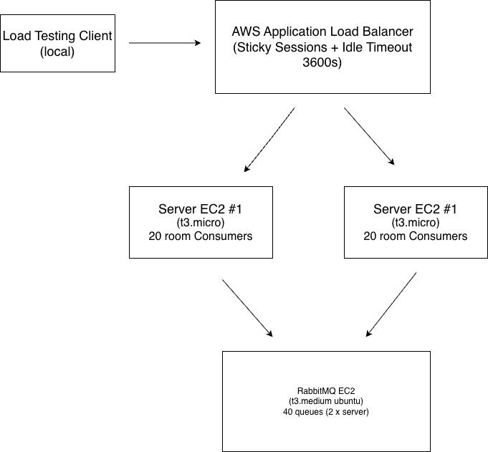

Message Flow Sequence
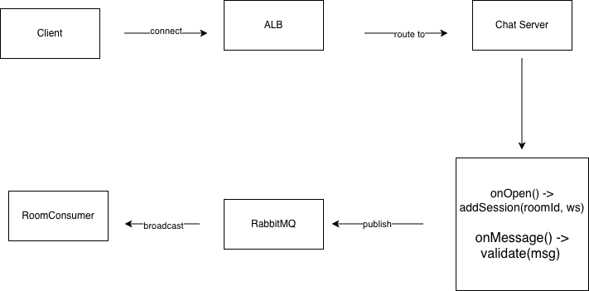

Queue Topology Design
A single topic exchange (chat.exchange) routes messages to server-specific queues using routing key pattern room.{roomId}
Each server declares its own set of 20 queues on startup.
Total: 1 exchange + 40 queues (20 per server)
When any server publishes a message with routing key room.5, RabbitMQ delivers a copy to both room.5.server-1 and room.5.server-2. Each server's consumer broadcasts to its own connected clients, ensuring all clients in a room receive every message regardless of which server they connected to.

Consumer Threading Model:
Each server runs 20 consumer threads (one per room), each blocked on Thread.currentThread().join() waiting for RabbitMQ to push messages:
Thread safety: RoomSessionManager uses ConcurrentHashMap with Collections.newSetFromMap(new ConcurrentHashMap<>()) for the session sets, ensuring safe concurrent access from WebSocket handler threads and consumer threads.
Delivery guarantee: Manual acknowledgment (basicAck/basicNack) implements at-least-once delivery. Failed broadcasts are requeued for retry.

Load Balancing Configuration
Parameter | Value
Type | Application Load Balancer (Internet-facing)
Listener | HTTP port 80
Target protocol | HTTP port 8080
Health check path | /health (port 8081)
Health check interval | 30 seconds
Stickiness | Enabled (86400s duration)
Idle timeout | 3600 seconds
Algorithm | Least Outstanding Requests

Failure Handling Strategies
Client-side retry: Failed WebSocket sends are retried up to 5 times with exponential backoff. On connection failure, a new connection is established before retrying.
RabbitMQ at-least-once delivery: Messages are acknowledged only after successful broadcast. Failed broadcasts trigger basicNack with requeue, ensuring no message loss.
Server health checks: ALB health checks on /health endpoint every 30 seconds automatically removes unhealthy instances from the target group, routing traffic to remaining healthy servers.

------------------------------------------------Test Results---------------------------------------------------
- Single Instance: (20 client threads)
Queue depth: 4000
Message rates(publish/consume): 219/177
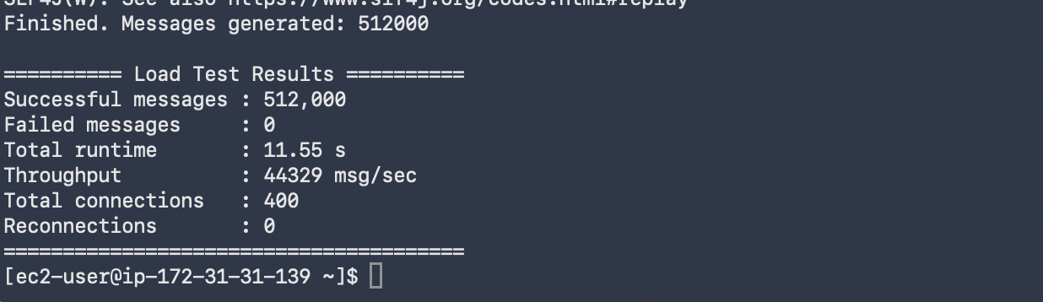
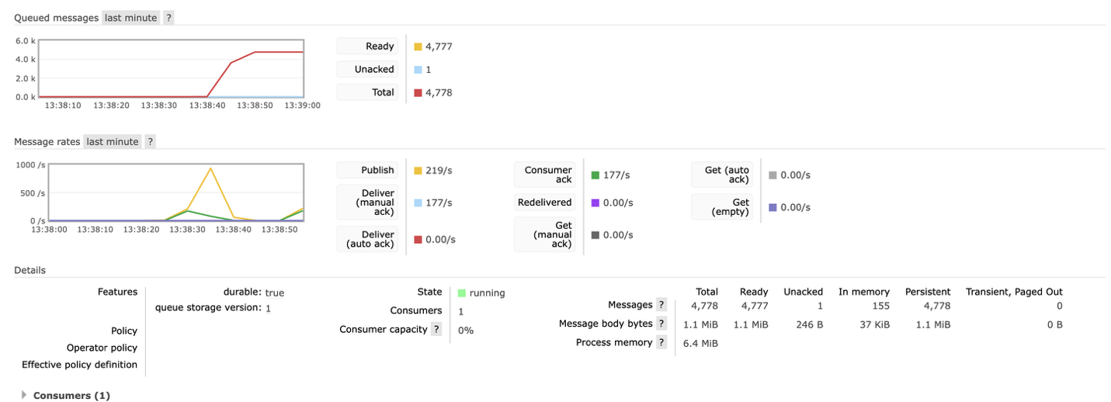
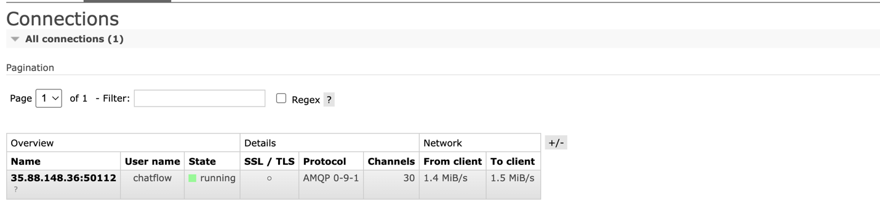
- 2 instances: (20 client threads)
Queue depth: 5000
Message rates(publish/consume): 400/300

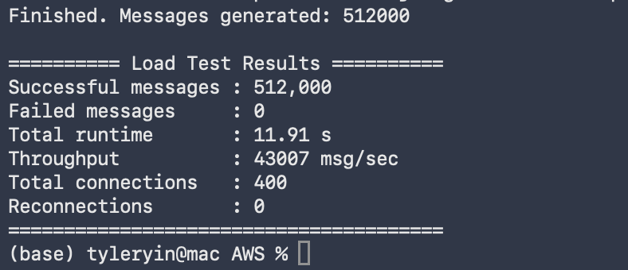
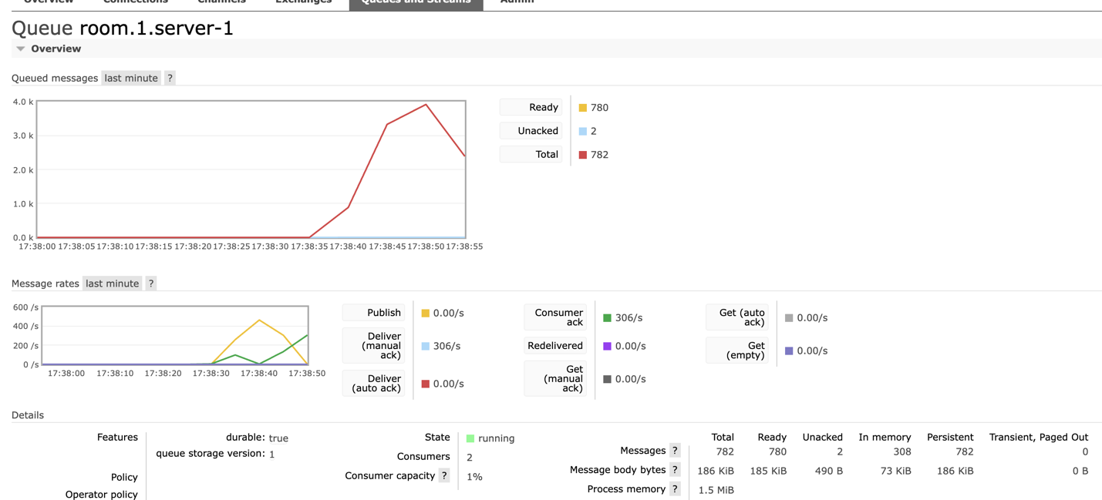
- 4 instances: (20 client threads)
Queue depth: 9000
Message rates(publish/consume):390/1

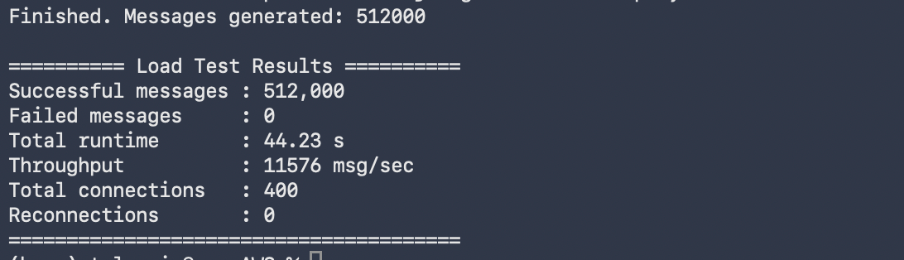
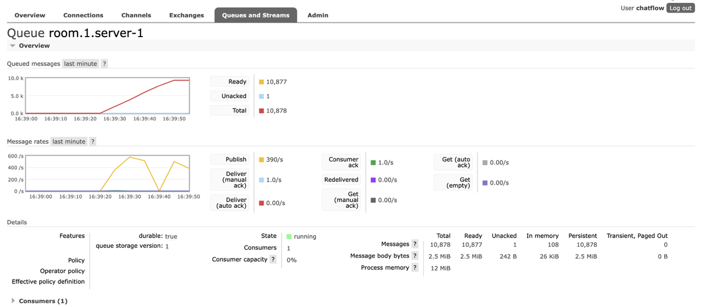
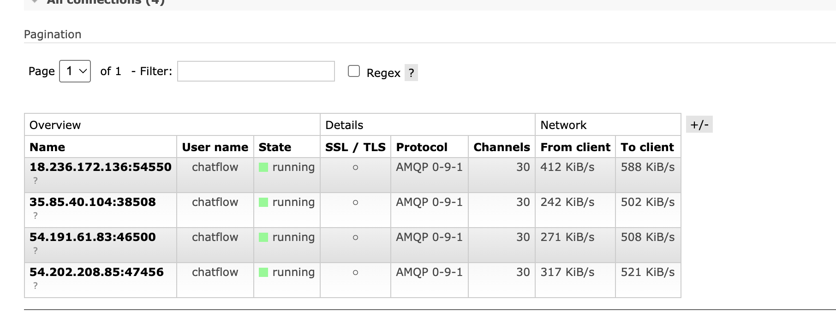
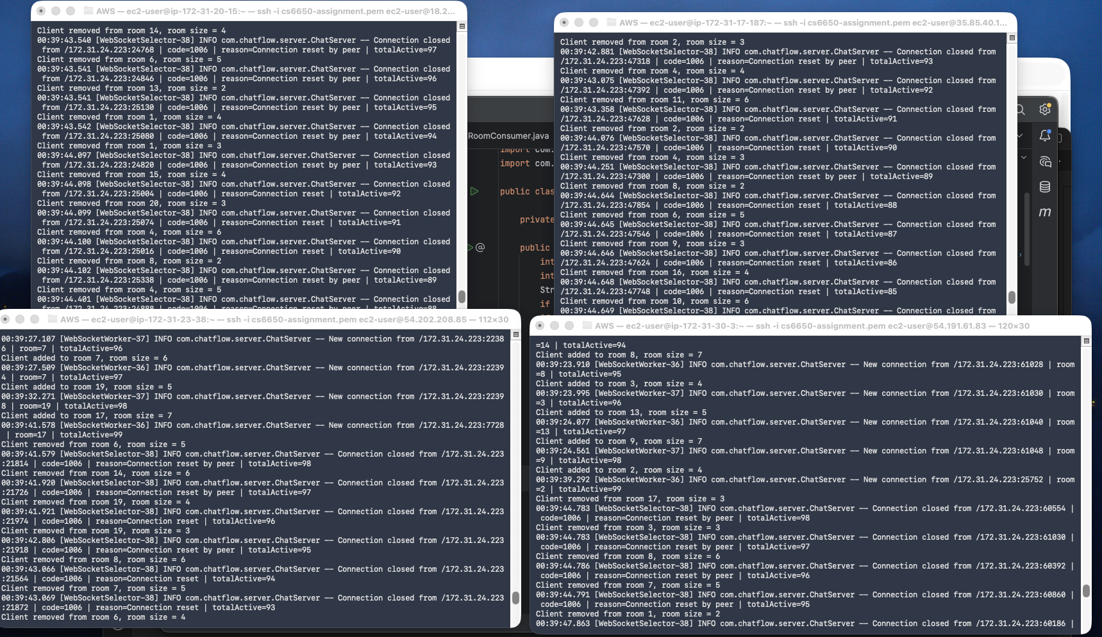

- Configuration Details

